7. Project Documentation Phase
Objective

To prepare complete documentation of the Auto Ticket Classification project, including the problem statement, requirements, design, development, testing, and final workflow.

Documentation Activities

- Document the project objective.
- Document the identified problem.
- Document the proposed solution.
- Document functional requirements.
- Document ticket classification rules.
- Document the system design.
- Document the Flow Designer development process.
- Document testing activities and results.
- Capture relevant screenshots.
- Prepare workflow and data flow diagrams.
- Document the final project outcome.
- Organize the project documentation phase-wise.

Documents Prepared

The documentation includes:

1. Project Introduction
2. Brainstorming & Ideation
3. Requirement Analysis
4. Project Design
5. Project Planning
6. Project Development
7. Project Testing
8. Project Demonstration
9. Screenshots
10. Workflow / Data Flow Diagram
11. Conclusion

Expected / Produced Output

A complete project document is produced containing all important details of the Auto Ticket Classification system.

The documentation provides a clear record of how the project was planned, designed, developed, tested, and demonstrated.

Screenshots

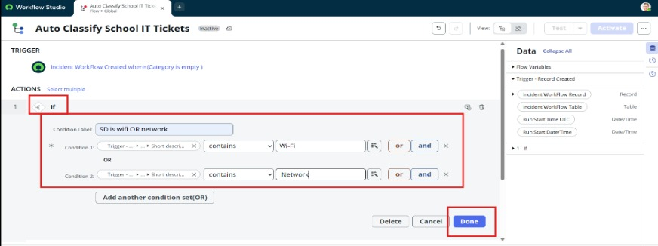
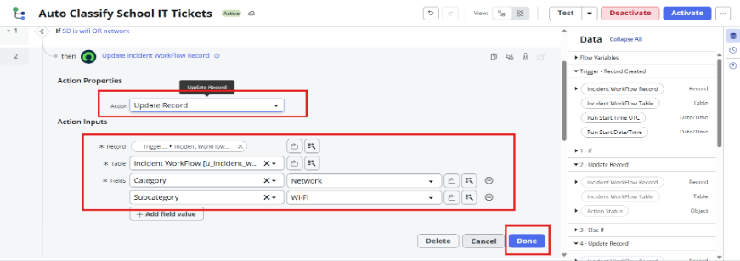

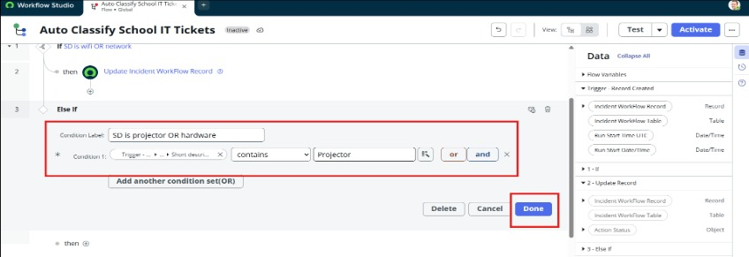

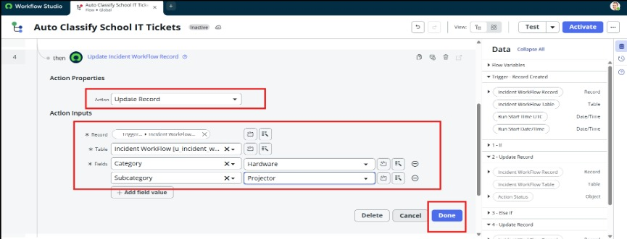
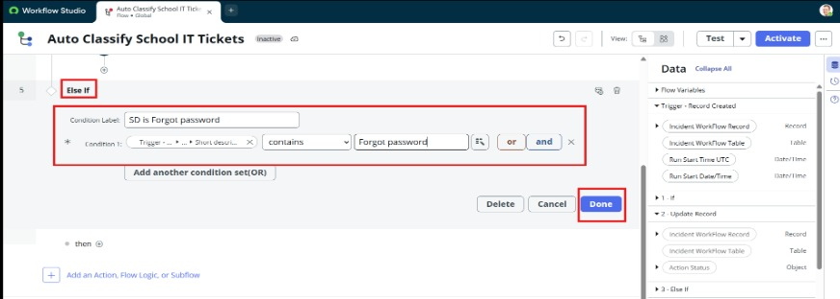

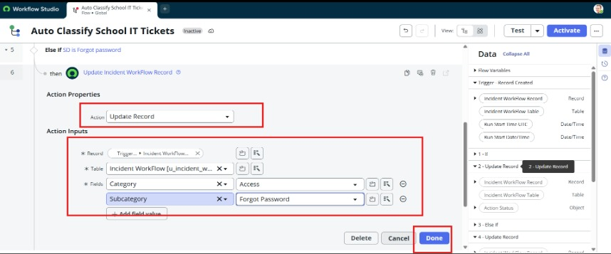

- Flow Designer configuration
- Trigger configuration
- Conditions
- Actions
- Test execution
- Final classified ticket

Data Flow Diagram
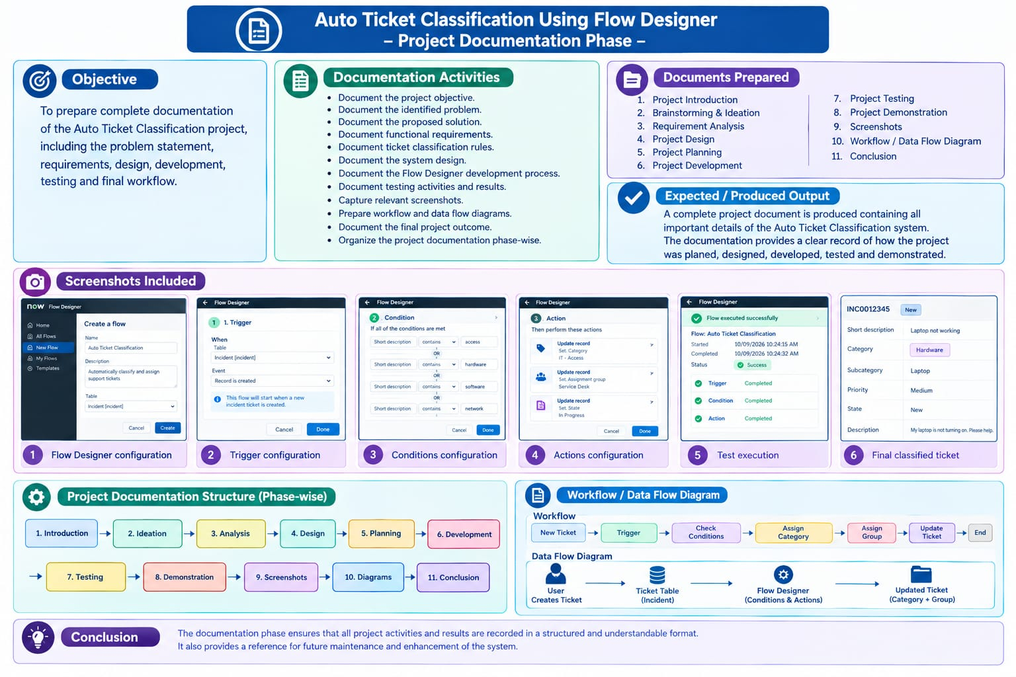

Conclusion

The documentation phase ensures that all project activities and results are recorded in a structured and understandable format. It also provides a reference for future maintenance and enhancement of the system.

